4CS001
Internet Software Architecture
&
Database

Lab Report

Name: Sagar Mishra
Group: 4
Student ID: np02cs4a250038

Module Leader Tutor
_______________ ______________

Table of Contents
Lab | Lab Title | Page No. | Tutor’s Signature
10 | 1. Prepare an activity diagram for computing a restaurant bill. There should be a charge for each delivered item. the total amount should be subject to tax. There is a service charge of 18% for groups of six or more and 10% for smaller groups. any coupons and gift certificates submitted by the customer should be subtracted. 4  2. For the case study given below identify all classes, their relationships, attributes and method for each class. Also draw class diagrams using standard UML notation. XYZ Marina is privately owned corporation that rents boats and provides boat services on a lake. The corporation needs an automated system to track customers, leased slips(Each space for boat in lake) and boats in the slips. The corporation has two types of boats sail boats and power boat. Both types of boats are uniquely identified by their attributes like registration number, manufacture year and boat length. The boat can be leased on daily basis or yearly basis. the system should perform following tasks creating lease, computing lease amount, assigning boats. The system should have features of search for vacant slips leased to specific customers and generating customized reports. The system should have to implement billing system as well. 5  3. Draw a complete UseCase Diagram with proper UML notation for the following case study. university registrars maintain data about the following entities: Courses, including number, title, credits, syllabus and prerequisites; Course offerings, including course number, year, semester, section number, instructors, timing and classrooms; students, including student id, name and program; and instructors, including identification number, name, department, and title. Further the enrollment of students in courses and grades awarded to students in each course they are enrolled for must be appropriately modeled. 6  4. Draw a sequence diagram of Online Order processing System. Uses five scenarios as follows: User, OrderTaker, CreditCardAgent, OrderFulfillment, BillingAgent. 7

Name / Sign of Module Leader Name / Sign of Module Leader

_________________ ___________________
Date: Date:

Prepare an activity diagram for computing a restaurant bill. There should be a charge for each delivered item. the total amount should be subject to tax. There is a service charge of 18% for groups of six or more and 10% for smaller groups. any coupons and gift certificates submitted by the customer should be subtracted.
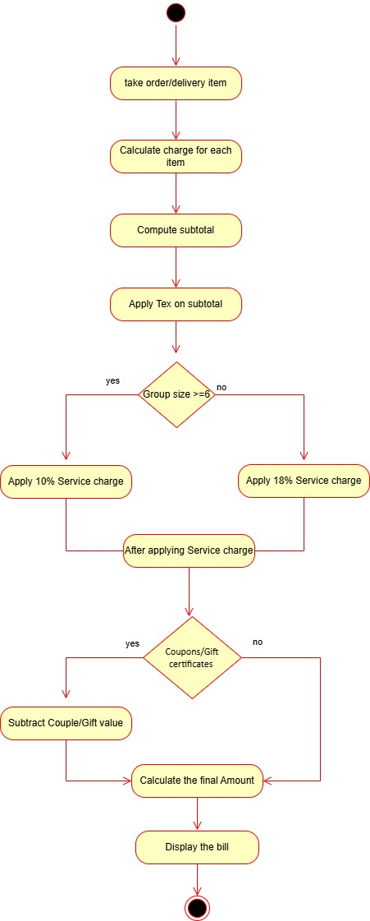

For the case study given below identify all classes, their relationships, attributes and method for each class. Also draw class diagrams using standard UML notation. XYZ Marina is privately owned corporation that rents boats and provides boat services on a lake. The corporation needs an automated system to track customers, leased slips(Each space for boat in lake) and boats in the slips. The corporation has two types of boats sail boats and power boat. Both types of boats are uniquely identified by their attributes like registration number, manufacture year and boat length. The boat can be leased on daily basis or yearly basis. the system should perform following tasks creating lease, computing lease amount, assigning boats. The system should have features of search for vacant slips leased to specific customers and generating customized reports. The system should have to implement billing system as well.

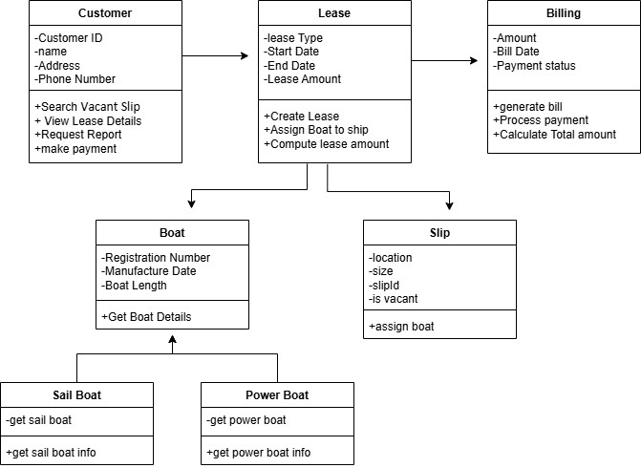

Draw a complete UseCase Diagram with proper UML notation for the following case study. university registrars maintain data about the following entities: Courses, including number, title, credits, syllabus and prerequisites; Course offerings, including course number, year, semester, section number, instructors, timing and classrooms; students, including student id, name and program; and instructors, including identification number, name, department, and title. Further the enrollment of students in courses and grades awarded to students in each course they are enrolled for must be appropriately modeled.
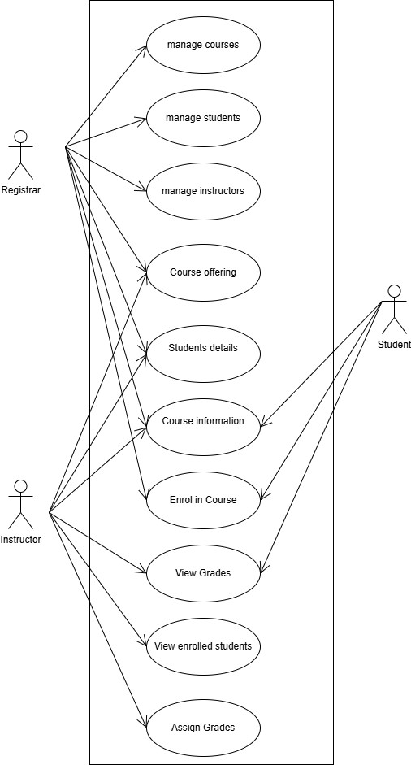

Draw a sequence diagram of Online Order processing System. Uses five scenarios as follows: User, OrderTaker, CreditCardAgent, OrderFulfillment, BillingAgent.

